SIMATS ENGINEERING

ASSESSMENT TOOL 2

COURSE NAME: Ethical Hacking COURSE CODE: ITA1435

COURSE OUTCOME COVERED
CO2: Execute footprinting in social engineering such as DNS analysis, competitive intelligence gathering, and attack simulations to collect relevant information for identifying potential security risks.
Assessment Tool Weightage: 30%
Duration: 90 min Total Marks: 50

Social Engineering Simulation

Questions

- As a Security Analyst, perform an OSINT-based email enumeration assessment on the target domain tesla.com using theHarvester in Kali Linux. Collect publicly available email addresses, subdomains, hosts, and IP addresses associated with the organization. Categorize the discovered email addresses into likely roles such as Support, Sales, Human Resources, Administration, and Technical Teams. Analyze how the gathered information could assist an attacker during the reconnaissance phase and explain how it could be used for spear-phishing, credential harvesting, and impersonation attacks. Finally, recommend at least five countermeasures to reduce information leakage and social engineering risks, and submit a report with screenshots, commands executed, findings, risk analysis, and recommendations. (20 Marks)
- As a cybersecurity awareness consultant, you are required to conduct a phishing awareness simulation using GoPhish and dummy employee accounts provided in the lab. Create an email template, launch a campaign, monitor user interactions, and generate a report showing delivery rate, email open rate, and click rate. Based on the results, provide recommendations to improve user awareness against phishing attacks.(20 Mark).
- Using Nmap Aggressive Scan (-A) on scanme.nmap.org, gather detailed information about the target including operating system details, open ports, and service versions. Assume you are an attacker and describe how the collected information could be leveraged to conduct a social engineering attack against the IT support team. Prepare a report explaining the attack methodology and defensive recommendations.(10 Marks)

Code of Conduct:

I P.Akhilkumar (192373024(Name / Reg No) certify that this submission is my original work and that I have adhered to the guidelines specified for this assessment.
I understand that any violation of academic integrity rules will result in disciplinary action.

Signature of the student: P.Akhil

RUBRICS FOR CALCULATION

Social Engineering Simulation

Criteria | Weightage (%) | Level 4 (Exemplary) | Level 3 (Proficient) | Level 2 (Developing) | Level 1 (Beginning)
Understanding of Social Engineering Scenario | 20% | Demonstrates a comprehensive understanding of the social engineering scenario, attack techniques, and security context | Demonstrates good understanding with minor omissions. | Shows partial understanding but misses important aspects of the scenario. | Fails to understand or incorrectly interprets the social engineering scenario.
Identification of Attack and Vulnerabilities | 20% | Correctly identifies the attack type, exploited vulnerabilities, and affected assets with complete accuracy | Correctly identifies most attack techniques with minor errors. | Identifies only some attack methods and vulnerabilities. | Unable to identify the attack type or associated vulnerabilities.
Application of Security Concepts and Countermeasu res | 25% | Effectively applies cybersecurity concepts and recommends appropriate preventive, detective, and corrective countermeasures. | Applies relevant concepts with minor errors and recommends suitable countermeasures  . | Applies concepts partially with limited recommendation s. | Unable to apply relevant cybersecurity concepts or recommend suitable countermeasures  .
Risk Analysis and Decision Making | 20% | Performs logical risk analysis, evaluates business impact, and provides well-justified security decisions. | Provides reasonable analysis with adequate justification. | Performs limited analysis with weak justification. | Provides no meaningful analysis or justification.
Clarity, Documentatio n and  Technical Presentation | 15% | Response is well-organized, technically accurate, professionally documented, and logically presented. | Response is clear with minor documentation or presentation issues. | Response lacks organization and contains  technical inaccuracies. | Response is poorly organized, incomplete, and difficult to understand.

Question 1
As a Security Analyst, perform an OSINT-based email enumeration assessment on the target domain tesla.com using theHarvester in Kali Linux. Collect publicly available email addresses, subdomains, hosts, and IP addresses associated with the organization. Categorize the discovered email addresses into likely roles such as Support, Sales, Human Resources, Administration, and Technical Teams. Analyze how the gathered information could assist an attacker during the reconnaissance phase and explain how it could be used for spear-phishing, credential harvesting, and impersonation attacks. Finally, recommend at least five countermeasures to reduce information leakage and social engineering risks, and submit a report with screenshots, commands executed, findings, risk analysis, and recommendations. (20 Marks)

Introduction
Open-Source Intelligence (OSINT) is the process of collecting and analyzing information that is publicly available from websites, search engines, public records, and other permitted sources. In this assessment, theHarvester in Kali Linux is used in an authorized lab to examine information associated with tesla.com, such as publicly indexed email addresses, subdomains, hostnames, and IP-address information. The objective is to understand what an outsider might discover and recommend ways to reduce unnecessary exposure. Public information is not automatically a vulnerability; risk depends on its sensitivity and how easily it can be combined with other information. The assessment must remain within the approved scope. It should not attempt to access accounts, send deceptive messages, or disrupt systems. The final report should distinguish observed facts from assumptions and protect sensitive information.

OSINT Data Collection and Analysis
In an approved lab, theHarvester can query supported public sources for information associated with a domain. A typical command pattern is `theHarvester -d example.com -b <source>`; replace the example domain with the assigned domain and select a source supported by the installed version. Follow the tool’s help output and instructor’s directions. Record the date, source, exact command, and results so the assessment can be reproduced. Possible findings include email addresses, subdomains, hostnames, and IP addresses returned by public sources. Not every result is current or owned by the organization; third-party services, old records, and false positives may appear. Validate results using reliable public sources and mark confidence as high, medium, or low. Take screenshots showing the command and representative output, but avoid publishing unnecessary personal details. Summarize the number and types of results rather than copying large contact lists into the report. Do not invent findings if the tool returns no results.
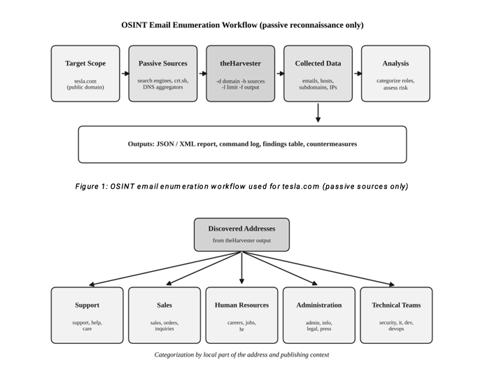

Categorization of Email Addresses
Email addresses can be grouped by likely function using naming patterns and publicly available context. Addresses containing terms such as `support`, `help`, or `service` may indicate Support; `sales`, `business`, or `partners` may indicate Sales; and `careers` or `jobs` may relate to recruitment or Human Resources. Terms such as `admin` or `office` may indicate Administration, while `security`, `it`, `dev`, or `engineering` may suggest Technical Teams. These are tentative categories, not verified job titles. Do not assign an individual to a department based only on a name; use “unknown” or “unverified” where appropriate. A report table can include a masked address or reference, inferred category, evidence, confidence, and risk. Avoid publishing a complete employee contact list unless explicitly authorized. The purpose is to identify patterns that may enable targeted impersonation, not to profile individuals unnecessarily.

Analysis of Social Engineering Risks
Public email addresses can help an attacker choose recipients and tailor convincing messages. A message aimed at Support might imitate a customer issue, while a message aimed at recruitment could refer to a résumé or job application. Technical staff might receive a fake software alert or security notice. Combining email addresses with subdomains and public staff information may make impersonation more credible. A spear-phishing message may use a familiar department name and urgent language to encourage a recipient to click a link or open an attachment. A fake login page could attempt to collect credentials, while an impersonated sender might request confidential files or an unauthorized payment. Hostnames and IP addresses can also reveal public-facing technology and guide further reconnaissance. However, OSINT results alone do not prove an attack has occurred or that a system is vulnerable. Any real employee simulation requires separate formal authorization.

Recommended Security Countermeasures
The organization should apply several complementary controls. First, review public websites and documents for unnecessary employee details, internal naming conventions, and technical metadata; remove or mask information that is not needed. Second, use role-based contact mailboxes where practical rather than publishing individual addresses unnecessarily. Third, configure SPF, DKIM, and DMARC correctly to reduce domain spoofing and monitor reports for abuse. Fourth, provide regular phishing-awareness training so staff check sender details, inspect links, verify unexpected requests through a separate trusted channel, and report suspicious messages. Fifth, enable multi-factor authentication, preferably phishing-resistant methods for privileged and high-risk accounts. Sixth, deploy email filtering, URL protection, attachment scanning, and endpoint security. Seventh, inventory public subdomains and hosts, remove abandoned DNS records, patch exposed services, and restrict administrative interfaces. Eighth, establish an incident-reporting process and practise account recovery, session revocation, and response to suspected credential theft. Repeat OSINT assessments periodically to measure improvement.

Conclusion and Report Submission
An OSINT email-enumeration assessment shows how much organizational information may be discoverable without internal access. Findings should be verified, categorized cautiously, and assessed for their potential to support reconnaissance and impersonation. Important improvements include limiting unnecessary public exposure, strengthening email authentication, training employees, protecting accounts with multi-factor authentication, and monitoring public-facing assets. The report should include the objective and authorized scope, Kali Linux and tool version, exact commands executed, screenshots of representative output, a summary of email and infrastructure findings, categorization method, risk analysis, and prioritized recommendations. Include the date and limitations, such as unavailable sources or uncertain results. Do not invent results. Store screenshots and contact details securely and share them only with authorized reviewers. A follow-up assessment can show whether corrective actions reduced exposure.

Question 2
As a cybersecurity awareness consultant, you are required to conduct a phishing awareness simulation using GoPhish and dummy employee accounts provided in the lab. Create an email template, launch a campaign, monitor user interactions, and generate a report showing delivery rate, email open rate, and click rate. Based on the results, provide recommendations to improve user awareness against phishing attacks. (20 Marks)

Introduction
Phishing awareness simulations help organizations understand whether employees recognize suspicious emails and report them appropriately. GoPhish can be used in a controlled training environment to send simulated messages and measure interactions. This exercise must use only the dummy employee accounts supplied for the lab, not real recipients or real credentials. Key measures include delivery rate, open rate, click rate, and, if configured, reporting rate. These measures identify where training and email controls may need improvement. The goal is to build safe habits, not to embarrass or punish participants. Before starting, define the scope, obtain authorization, choose a harmless scenario, and ensure that only the minimum interaction data needed for the exercise is recorded.

OSINT Data Collection and Analysis
Although this task focuses on GoPhish rather than OSINT, campaign preparation still requires approved data handling. Use only the dummy addresses supplied by the instructor and confirm that messages cannot reach external recipients. Prepare a harmless training scenario, such as a routine internal notice, without using real passwords or an external sign-in page. The typical lab workflow is to configure the sending profile, prepare an email template and any required landing page, select the approved test group, launch the campaign, and review the results dashboard. Interface labels may differ by version, so follow the installed version and lab guide. Record the campaign name, date, recipient count, and relevant settings. Screenshots should show configuration and aggregate results, with identifiers masked when unnecessary. If delivery fails, record the error rather than treating the recipient as having ignored the message.

Categorization of Email Addresses
For a GoPhish simulation, categorize recipients by test group or training cohort rather than collecting unnecessary personal information. Dummy addresses can use groups such as “Group A” and “Group B,” if assigned by the instructor. Unique test identifiers allow results to be reviewed without exposing identities. The report should distinguish delivery, open, link click, and message report events. These events are not equivalent: an email can be delivered but not opened, and some clients automatically load tracking pixels or scan links, affecting recorded open and click rates. Therefore, metrics are indicators rather than perfect proof of human behavior. Delivery rate is delivered messages divided by attempted sends, multiplied by 100. Open rate is commonly unique recorded opens divided by delivered messages, multiplied by 100. Click rate is commonly unique recorded clicks divided by delivered messages, multiplied by 100, though organizations may use a different denominator. State the formula used and apply it consistently.
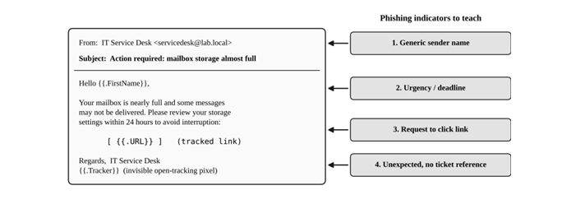

Analysis of Social Engineering Risks
A simulation can show whether recipients respond to common social-engineering techniques. High click rates may suggest that users do not check link destinations or respond to urgency without verifying the sender. An open is a weaker signal because automatic image loading can register an open without the recipient reading the email. Clicking a link does not necessarily mean that information was entered or that compromise occurred. In a real attack, a deceptive link could lead to a credential-harvesting page, and an attachment could contain malicious content. An attacker might impersonate IT support, HR, a supplier, or a manager to make a request seem routine. If credentials were disclosed in a real incident, the attacker could attempt to access email or cloud applications, send further phishing messages, or retrieve sensitive information. A safe simulation must not collect real passwords or deploy malware. Report aggregate patterns, explain metric limitations, and recommend training without blaming individuals.
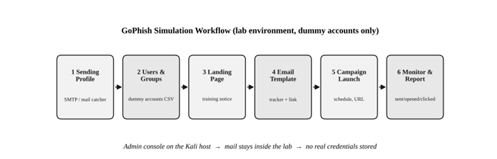

Recommended Security Countermeasures
Provide short, recurring awareness sessions using examples of suspicious sender addresses, unexpected attachments, mismatched URLs, urgency, password requests, and unusual payment instructions. Teach employees to verify sensitive requests through a separate trusted channel and report suspicious messages through a simple process. Use periodic, authorized simulations with varied scenarios and immediate educational feedback. Configure SPF, DKIM, and DMARC; deploy spam filtering, malicious URL checks, attachment sandboxing, and endpoint protection; and keep systems patched. Require multi-factor authentication, preferably phishing-resistant methods for privileged accounts. Restrict unnecessary privileges and maintain a response process for suspicious messages. For GoPhish, use only dummy recipients, approved scope, harmless templates, and a controlled mail environment. Do not capture actual passwords or send messages to external recipients. Track aggregate delivery, open, click, and reporting rates over multiple rounds. Encourage reporting and treat the exercise as a learning opportunity.

Conclusion and Report Submission
A GoPhish simulation provides useful evidence about how users interact with suspicious messages, but results must be interpreted carefully. Delivery, open, and click rates measure different events and may be affected by filters, image loading, or automated link scanning. The report should include objective, authorization and scope, dummy recipient count, campaign settings, template summary, screenshots, results, metric formulas, limitations, risk analysis, and prioritized recommendations. Use actual values from the lab dashboard and do not invent results. Conclude with the behaviors to improve and a plan for repeat training and measurement. Success should be judged not only by fewer clicks but also by faster reporting, better recognition, and effective technical defenses. Employee education combined with email authentication, filtering, multi-factor authentication, and a supportive reporting culture reduces phishing risk.
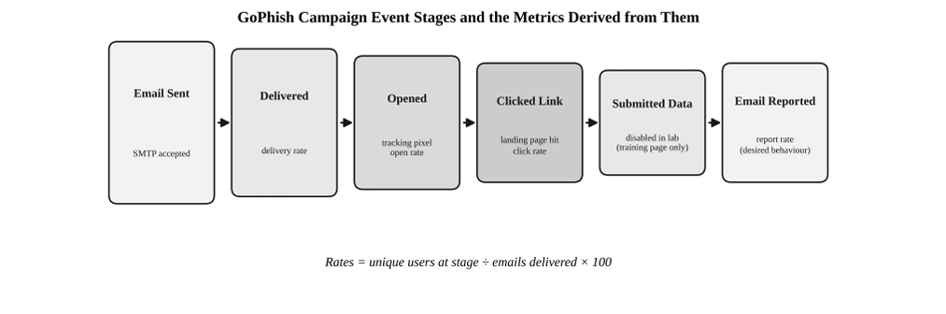

Question 3
Using Nmap Aggressive Scan (-A) on scanme.nmap.org, gather detailed information about the target including operating system details, open ports, and service versions. Assume you are an attacker and describe how the collected information could be leveraged to conduct a social engineering attack against the IT support team. Prepare a report explaining the attack methodology and defensive recommendations. (10 Marks)

Introduction
Nmap is a network exploration and security auditing tool that identifies reachable hosts, open ports, service information, and possible operating-system details. The target scanme.nmap.org is provided by the Nmap project for limited scanning practice; testing must remain within its published permission and usage limits. Nmap’s `-A` option enables several detection features, including operating-system detection, service/version detection, default scripts, and traceroute where supported. This exercise examines what a defender can learn and how such information could increase social-engineering risk. It must not involve attacking the host, disrupting services, or contacting real IT staff with deceptive messages. The report should separate information actually observed from hypothetical attacker behavior and focus on defensive analysis.
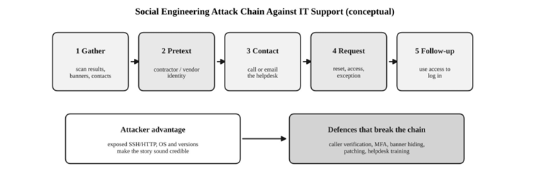

OSINT Data Collection and Analysis
For the authorized lab, a typical command is `nmap -A scanme.nmap.org`. Run it only within the target’s published scanning permission and the lab instructions; do not add aggressive rates, denial-of-service tests, or unrelated targets. Record the date, Nmap version, exact command, and output. Results may identify open TCP ports, service names and versions, possible operating-system details, and traceroute information, but findings can change over time. Some detections may be uncertain because of filtering or network conditions. Capture a screenshot of the terminal output and summarize observations in a table with port, service, detected version, evidence, and confidence. Do not claim a port or version was found unless it appears in the actual output. Use the scan only to illustrate the type of information a threat actor might learn; do not target real employees or attempt unauthorized access.

Categorization of Email Addresses
This question does not require collecting employee email addresses, and a network scan alone does not normally provide a verified list of staff contacts. For social-engineering analysis, categorize potential information sources rather than inventing email addresses. Public technical documentation may describe supported systems; a public website may list general support channels; and job descriptions may outline broad responsibilities. Use such information only if it is genuinely public and within the assignment scope. Avoid identifying individual staff or creating personal contact lists when they are unnecessary. In the report, separate “technical details observed by Nmap” from “organizational information that might be public elsewhere.” Scan output does not prove an employee’s name, role, email address, or authority. If a categorization section is required, explain that no email enumeration was performed and describe hypothetical role categories such as IT support, system administration, and security operations.

Analysis of Social Engineering Risks
An attacker might use technical observations to make a deceptive message sound credible. If a scan identifies a web or remote-access service, for example, a message might pretend to report a service issue or claim that an urgent patch is required. A message could use technical terms, urgency, or a supposed ticket number to pressure IT support into sharing information or following unsafe instructions. Public descriptions of support processes could make an impersonation seem more convincing. A successful deception might persuade staff to disclose internal configuration details, reset an account for an unverified requester, or open a harmful attachment. This risk relies on trust and urgency, not solely on software flaws. However, scanning scanme.nmap.org does not authorize targeting the Nmap project’s IT team, and scan output does not prove any person is vulnerable. Keep the discussion conceptual and focus on safeguards that prevent unauthorized requests from succeeding.

Recommended Security Countermeasures
Organizations should reduce technical exposure by disabling unnecessary services, restricting administrative interfaces, applying updates, and using firewalls to allow only required traffic. Service banners should not reveal unnecessary version details, although hiding banners is supplementary and cannot replace patching. Monitor exposed services and conduct regular authorized assessments. To resist social engineering, train IT staff to verify identity before resetting accounts, disclosing configuration details, or acting on urgent requests. Require ticket references and independent verification for password resets, access changes, and sensitive requests. Staff must never disclose passwords, one-time codes, or confidential information in response to unsolicited messages. Use multi-factor authentication, role-based access, least privilege, endpoint protection, and centralized logging. Provide a simple reporting channel and practise incident response. Follow Nmap’s authorization and usage limits, preserve evidence, and avoid actions that could affect availability. Review scan findings, prioritize confirmed risks, remediate them, and retest within the approved scope.

Conclusion and Report Submission
An Nmap aggressive scan can provide an overview of reachable ports, services, versions, and possible operating-system details. Such information may support reconnaissance and make a social-engineering message seem technically convincing, but it does not itself prove a vulnerability or compromise. The report should include the objective, authorization scope, exact command, Nmap version, dated screenshots, observed results, confidence limitations, social-engineering risk analysis, and defensive recommendations. Use actual scan output and do not invent services, staff details, or attack outcomes. Strong defenses combine secure service configuration and patching with identity verification, multi-factor authentication, staff awareness, monitoring, and a clear reporting process. A responsible assessment documents findings and helps the system owner reduce risk rather than attempting to deceive or compromise real IT personnel.

